Linear Equation

Existence

There are three cases of linear equations (with no other restrictions)

|  |  |  |
| --- | --- | --- |
| $$rank\left(A\right)==rank\left(B\right)==m$$ | unique | $$A$$ can be reduced to row-echolen format. |
| $$rank\left(A\right)==rank\left(B\right)<m$$ | many | $$A$$ can NOT. And there are at least 1 row containing all 0 and its corresponding value is zero. |
| $$rank\left(A\right)<rank\left(B\right)$$ | No solution that satisfies requirements | $$A$$ can NOT, but the corresponding value is NOT zero. |

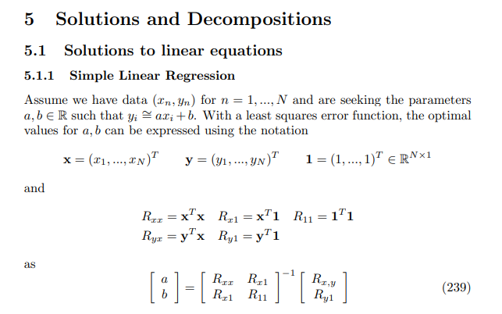

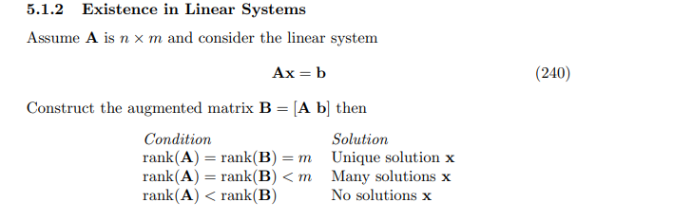

When the linear equations has unique solution $$x$$, $$x$$ will be the inverse or psuedo-inverse of $$A$$ over $$b$$. Exactly say,

|  |  |
| --- | --- |
| $$x=A^{−1}b$$ | $$A$$ Invertible and $$A$$ square. |
| $$x=A^{+}b$$ | $$A$$ Invertible and $$A$$ not square. |
| No solution | $$A$$ Non-invertible. |

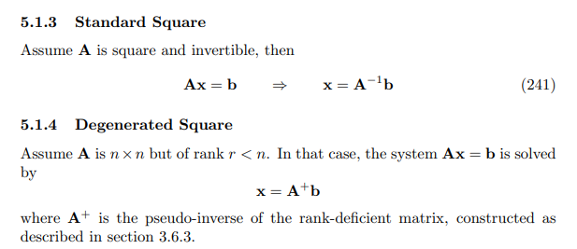

Determined rectangular matrix

Way to find

Cramer’s rule

When there are exactly one solution and $$A$$ is invertible and square. Then one can applied to Cramer’s rule.

$$x_{i}=\frac{\det\left(B\right)}{\det\left(A\right)}$$

where

$$x=\left[x_{1},…x_{n}\right]$$

$$B=\left[E_{r,w} \right]$$

$$E_{r,w}$$ = $$A_{r,w}$$, if $$w != i$$

$$E_{r,w}=b_{i}$$, otherwise

That is, $$B$$ is almost equal to $$A$$, but the ith column of $$A$$ is substitute by $$b$$.

Over-Determined rectangular matrix

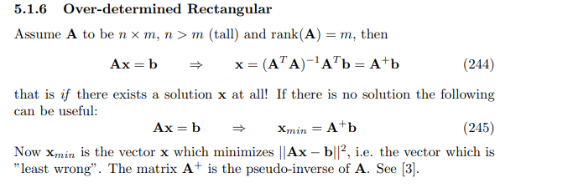

Under-determined rectangular matrix

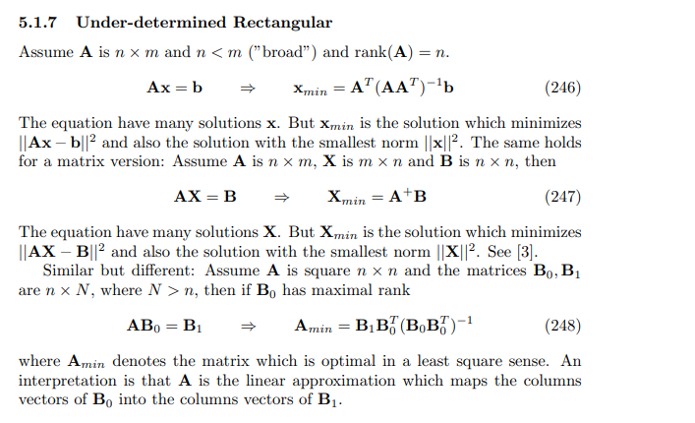

Special case

When $$x$$ is any vector.

|  |  |
| --- | --- |
| $$Ax=O$$ | $$A=O$$ |
| $$x^{T}Ax=O$$ | $$A=O$$ |

where

$$O$$ refers zero matrix

Ref

[Wayback Machine (archive.org)](https://web.archive.org/web/20090521075124/http://www2.imm.dtu.dk/pubdb/views/edoc_download.php/3274/pdf/imm3274.pdf)